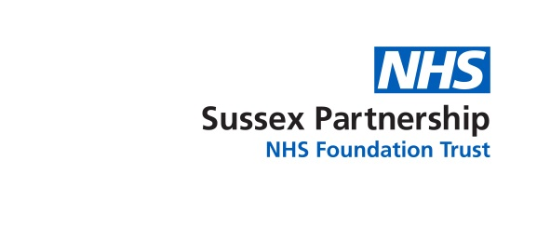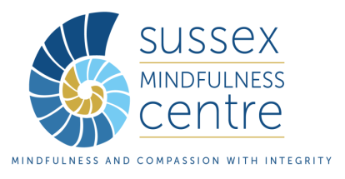

**Sussex Mindfulness Centre: Mindfulness Course for Trust Staff**

|  |  |  |  |
| --- | --- | --- | --- |
| **Equality Monitoring Information**  Sussex Partnership NHS Foundation Trust recognises and actively promotes the benefits of a diverse workforce. Completing this form is optional but is also a vital part of monitoring equality of opportunity in this scheme; the answers you give will not be reviewed by those selecting to the group. | | | |
| **Country of Birth** |  | | |
| **Nationality** |  | | |
| **Age** | 18-24 25-34  35-44  45-54  55-64  65-74 75+ | | |
| **Do you consider yourself to have a disability?**  **\*Please state the type of impairment which applies to you** | Yes* | No | Prefer not to say |
| Physical Impairment | Learning Difficulty / Disability | Sensory Impairment |
| Mental Health Problems | Long-standing illness | Other |
| **Ethnic Origin** | WHITE (A)British | WHITE (B) Irish | WHITE (C) Any other White Background |
| MIXED (D) White and Black Caribbean | MIXED (E) White and Black African | MIXED (F) White and Asian |
| MIXED (G) Any other mixed background | ASIAN or ASIAN BRITISH (H) | ASIAN or ASIAN BRITISH (J) Pakistani |
| ASIAN or ASIAN BRITISH (K) Bangladeshi | ASIAN or ASIAN BRITISH (L) Any other Asian background | BLACK or BLACK BRITISH (N) African |
| BLACK or BLACK BRITISH (P) Any other Black background | OTHER ETHNIC GROUP (R) Chinese | OTHER ETHNIC GROUP (S) Any other ethnic groups |
| Prefer not to say |  |  |
| **Gender** | Male | Female | Non-binary |
| Trans | Intersex person | Prefer not to say |
| Prefer to self-describe: | | |
| **Sexuality** | Lesbian | Gay | Bisexual |
| Heterosexual | Other | Prefer not to say |
| **Religion or Belief** | Atheism | Buddhism | Christianity |
| Islam | Jainism | Sikhism |
| Judaism | Hinduism | Prefer not to say |
| Prefer to self-describe: | | |